Business Requirements Document for LinkedIn

*Dillon Ward – G00326756 – Software Testing*

1.00 - Open Home page while logged in

2.00 – Go to the Home Page via URL while logged out

3.00 – Log in without entering any log in credentials (username/password)

4.00 – Log in using credentials

5.00 – Open ‘My Network’ and view my Connections

6.00 – Open an Image that’s on the Home page

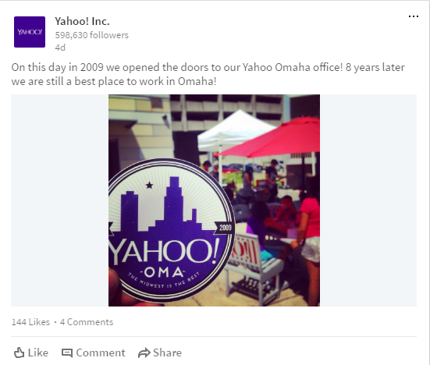

7.00 – Open Company Page and View Jobs that are posted by the company that has no jobs

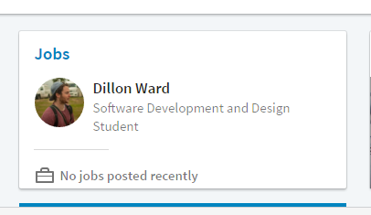

8.00 – Open a Company page and view jobs that are currently available for that company





9.00 – Open an article from the Home feed that has been either posted by a company or person

10.00 – Share an article from the Home feed that has been either posted by a company or person

11.00 – Share an Article from Home feed as a direct message to another user

12.00 – Write an update to and from the Home feed

13.00 – Send an invite to another user to add them to your connections

14.00 – Open the profile of another user

15.00 – Open your Network and view companies that are there along with the connections that are related to/work at the company

16.00 – Filter Job preferences to show different jobs

17.00 – Send a message through the message tab that can be found along the navigation bar

18.00 – Send a message through the messaging shortcut popup window

19.00 - View the accounts of other users who have viewed your account